**Ex No: 6**

**Date:**

**RECOGNIZE A VALID VARIABLE WITH LETTERS AND DIGITS USING LEX AND YACC**

**AIM:**

To recognize a valid variable which starts with a letter followed by any number of letters or digits.

**ALGORITHM:**

* Define lexical rules in variable.l with regex to match valid variables: start with a letter, followed by letters or digits. Tokenize input, distinguishing letters and digits.
* Use lexer (variable.l) to tokenize input into meaningful units like letters and digits.
* Implement grammar rules in parser (variable.y) for recognizing valid variable names using context-free grammar. Incorporate lexer tokens into parsing.
* In parser, implement error handling to detect invalid variable names. Set a flag (e.g., valid) to mark invalid identifiers.
* Check validity post-parsing; if flag remains true, indicate valid identifier. Otherwise, display message for invalid input.

**PROGRAM:**

**variable.l:**

%{

    #include "y.tab.h"

%}

%%

[a-zA-Z_][a-zA-Z_0-9]* return letter;

[0-9]                       return digit;

.                      return yytext[0];

\n                     return 0;

%%

int yywrap()

{

return 1;

}

**variable.y:**

%{

    #include<stdio.h>

    int valid=1;

%}

%token digit letter

%%

start : letter s

s :     letter s

      | digit s |;

%%

int yyerror()

{

    printf("\nIts not a identifier!\n");

    valid=0;

    return 0;

}

int main() {

    printf("\nEnter a name to test for an identifier: ");

    yyparse();

    if(valid) {

        printf("\nIt is a identifier!\n");

    } }

**OUTPUT:**

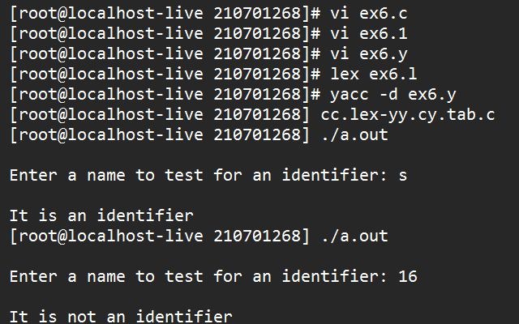

**RESULT:**